How Do We Understand Trust?
Theatre, AI and ‘Ludic Technologies‘: Humanist Perspectives
9th April , 2021
Thales has a breadth of experience across a number of domains, including space, maritime, rail and avionics. We’re currently working on a framework for trust that is applicable across these domains, with the aim of better understanding the impact that trust has on human-computer interaction, and the importance of designing and engineering systems with trust in mind. Our objective for a multi-disciplinary workshop was to go further than writing and distributing user requirements to explore creative approaches for better understanding of trust, designing for trust and communicating the importance of designing for trust. In order to achieve this, the workshop we organised explored how people view and understand concepts related to trust, and how we can communicate the importance of designing for trust.
Our first exercise focused on the evaluation of the trustworthiness of future systems. As a team, we evaluated the possible trust issues in two hypothetical scenarios: the use of autonomous vehicles to survey seabeds and the integration of intelligent machines into the human body. From here, we moved the discussion a bit closer to home, and asked people to consider the products and services that they currently use, and asked the following question: have these been designed with trust in mind? Using specific design questions around transparency, communication, and control, we evaluated the trust that we place in social media and our phones (our selected “use cases”).
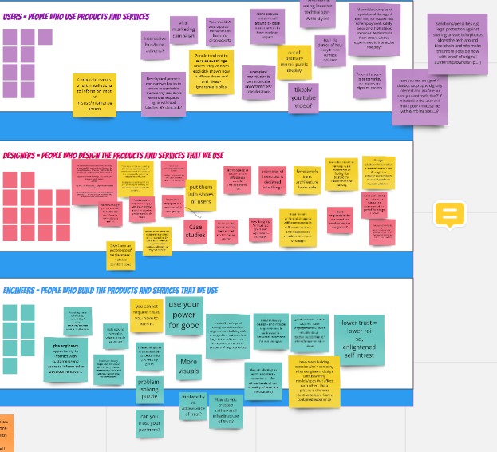
The final exercise was reflect upon the concerns that were raised through the session, and the understanding we’d gathered from our discussions, in a manner that contributed towards the development of ideas around communicating the importance of trust. We discussed our ideas for communicating trust to key stakeholders: users, designers and engineers (Figure 1). Through our discussions, some of the key ideas regarding communicating the important of trust that emerged included interactive role playing scenarios, escape rooms, interactive installations and digital conversation agents.
Figure 1. Exercise 3 on our Miro board.
Following on from the workshop, our aim is to use the ideas explored around trust concerns to inform our future research in the area. Ideally, Thales would like to explore the development of public engagement activities based on some of the ideas suggested.

